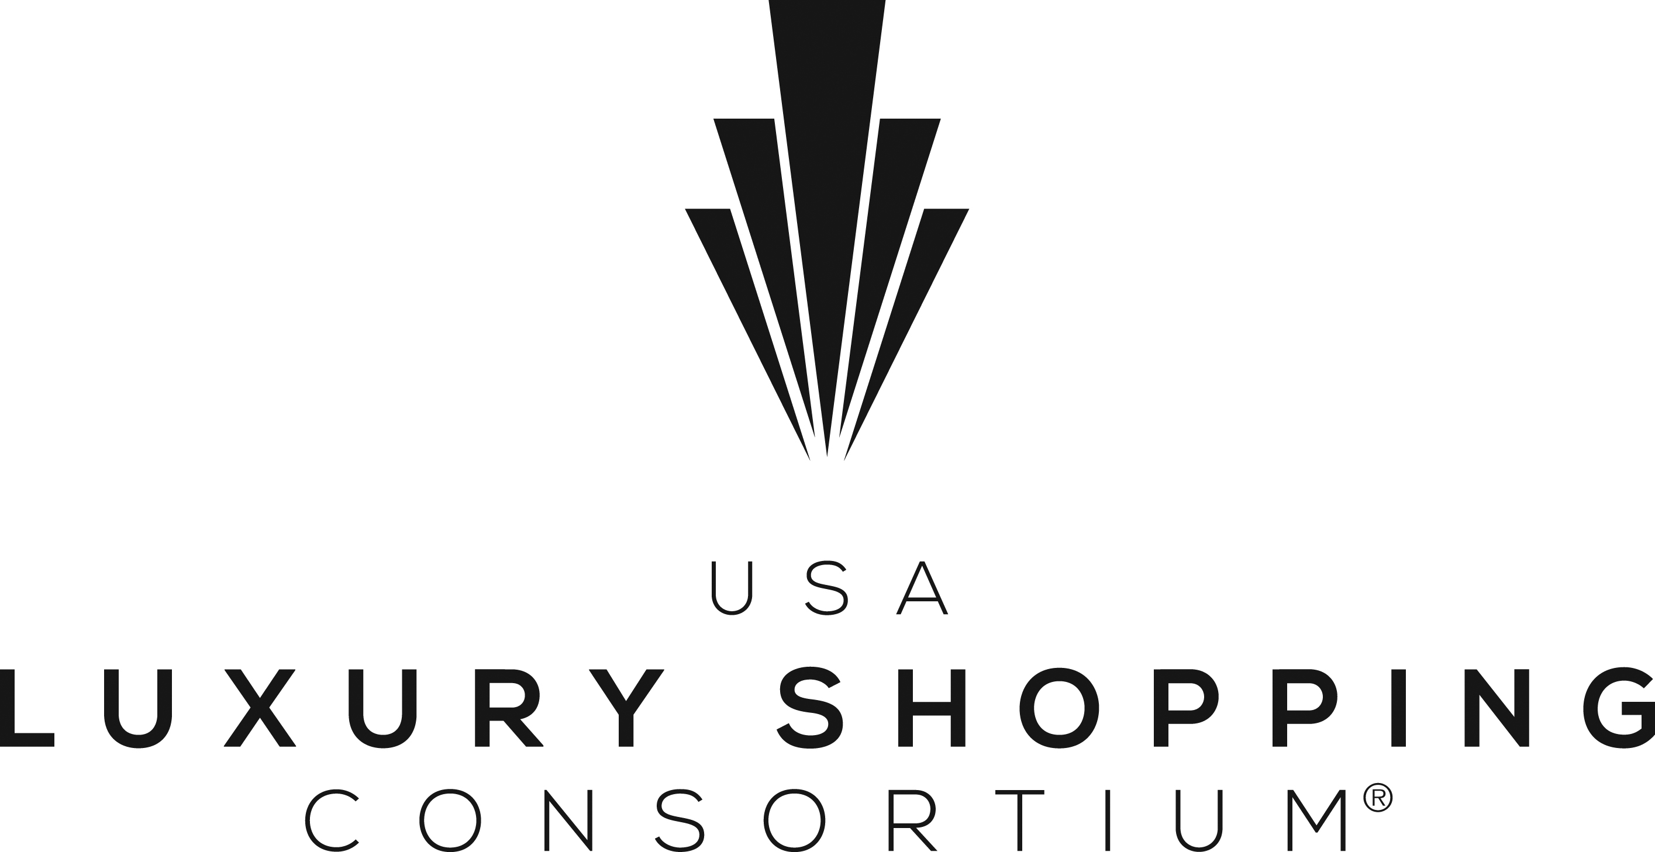

USA LUXURY SHOPPING CONSORTIUM JOINS VIRTUOSO® AS NEW LIFESTYLE PARTNER

December 16, 2016 – A new cooperative marketing partnership was announced today: the USA Luxury Shopping Consortium. The Consortium, consisting of 10 of America’s leading luxury shopping centers, located in nine of the top U.S. travel destinations and owned by five different shopping center development and management companies, has been accepted as a new Lifestyle Partner by luxury travel industry leader Virtuoso. The USA Luxury Shopping Consortium has chosen to partner with Virtuoso exclusively due to the access the network provides to a discerning global clientele.
Virtuoso is the preeminent international travel agency network specializing in luxury and experiential travel. This by-invitation-only organization comprises over 740 travel agency locations with more than 11,400 elite travel advisors in over 40 countries throughout North America, Latin America, the Caribbean, Europe, Asia-Pacific, Africa and the Middle East. Virtuoso travel advisors serve the most affluent, well-traveled individuals in the world and represent the top 1% of travel agencies measured by service, offerings, reputation and luxury travel sales.
The USA Luxury Shopping Consortium showcases some of the finest retail names and designer labels found in America including Louis Vuitton, Hermès, Dior, Tom Ford, Gucci, Prada, Jimmy Choo and more. These brands are highly coveted by affluent travelers from around the world. As a result, all the Consortium centers have had well-established and award-winning international tourism marketing programs in place for many years. The Virtuoso partnership affords them the opportunity to communicate their retail and dining offerings to a new luxury-minded client base.
Through this partnership, the USA Luxury Shopping Consortium will be marketed via print and digital channels to Virtuoso travel advisors and their clients. In addition, the Consortium will present advisor training webinars on the importance of including luxury shopping and sought-after culinary experiences in their clients’ travel itineraries. All the Consortium’s shopping and dining destinations offer a variety of visitor services, special offers, amenities and experiences for both domestic and international fully
(more)
independent travel (FIT) travelers and groups. The Consortium will also meet personally with Virtuoso agency owners, managers and travel advisors at the Fashion Week of Travel, Virtuoso Travel Week, in Las Vegas in August.
“This partnership will provide our travel advisors with a new kind of experience to offer their clients in a variety of highly desirable U.S. destinations,” said Angela Roditi, vice president, Alliances at Virtuoso. “Virtuoso clients are passionate about enjoying shopping and dining experiences during their travels, and this new partnership with the USA Luxury Shopping Consortium will mean they’re treated like VIPs, offering them valuable benefits at these centers.”
The USA Luxury Shopping Consortium destinations from east to west include:
Washington, D.C. – Tysons Corner Center Just minutes from downtown Washington, D.C., Tysons Corner Center is the Nation’s Capital choice for selection, style and fashion. World-class shopping, dining and entertainment converge to offer the visitor a monumental experience. As one of the top 10 shopping centers in the country, Tysons Corner Center offers an unbeatable mix of more than 300 department and specialty stores. Tysons’ “who’s who” of retailers includes American Girl, Apple, Bloomingdale’s, Gucci, Lenkersdorfer Fine Jewelers, Lord & Taylor, Louis Vuitton, Macy’s, Michael Kors, Nordstrom, and more. Tysons Corner Center also offers a 16-screen stadium seating and IMAX 3D AMC Theatre, fine and casual dining restaurants, a food court, center-wide WiFi and a National Geographic sponsored children’s play area. The new outdoor Plaza at Tysons Corner hosts events throughout the year and provides a number of eateries with cafe seating. The new 310-room luxury Hyatt Regency Hotel at Tysons Corner Center is the perfect respite from a busy day of shopping. www.tysonscornercenter.com
Atlanta, Georgia – The Shops Buckhead Atlanta A beautifully landscaped outdoor shopping and dining district showcasing over 50 fashionable retailer shops, restaurants and cafes. Visitors will discover dozens of traditional luxury brands and contemporary designer labels found nowhere else in Atlanta including Dior, Hermes, Jimmy Choo, Brunello Cucinelli, Tom Ford, COS, Akris, Alice & Olivia and more. Dining options include Le Bilboquet, Gypsy Ktichen, The Southern Gentleman, Fado Irish Pub and others. Travelers also enjoy an Urbana Wellness Spa, FlyWheel Cycling Studio and luxurious Venetian Nail Spa. Visitors receive a Global Access Card entitling them to special offers, services and experiences including complimentary transportation from nearby luxury hotels, valet, personal stylist assistance, hotel package delivery, mini-facials, hotel room fittings, alterations, in-store champagne, espresso, dining discounts, gifts with purchase and more. www.theshopsbuckheadatlanta.com
Houston, Texas – River Oaks District Houston Discover over 65 luxury designer boutiques, shops, restaurants and cafes set amidst beautiful tree-lined streets with lush landscaping. Dozens of renowned retail brands, located nowhere else in Houston, include Dior, Hermes, Cartier, Tom Ford, Harry
(more)
Winston, Dolce & Gabbana, Van Cleef & Arpels, Brunello Cucinelli and more. Dining options include Le Colonial, Steak 48, SumoMaya,Taverna, Toulouse Café and others. Travelers also enjoy a Venetian Nail Spa, iPic luxury Movie Theater with The Tuck Room dining and a Concierge Desk. Visitors receive a Global Access Card entitling them to special offers, services and experiences including complimentary transportation from nearby hotels, valet, personal stylist assistance, hotel package delivery, mini-facials, hotel room fittings, alterations, shoe shines, in-store champagne, espresso, dining discounts, gifts with purchase and more. TaxFree Shopping for international travelers. www.riveraoksdistrict.com
Scottsdale, Arizona – Scottsdale Fashion Square In the heart of Downtown Scottsdale, Scottsdale Fashion Square offers visitors a compelling indoor shopping, dining and entertainment experience. World famous art galleries, restaurants and resorts are all located within walking distance of Arizona’s premier shopping destination. In Scottsdale, where shopping is a top passion for national and international visitors, Scottsdale Fashion Square offers the very best in every category. Top brands beckon at every turn –Neiman Marcus, Nordstrom, Macy’s and Dillard’s anchor retailers such as Boss Hugo Boss, Bottega Veneta, Bulgari, Burberry, Cartier, CH Carolina Herrera, Escada, Gucci, Jimmy Choo, Louis Vuitton, kate spade new york, Salvatore Ferragamo, Tiffany & Co., Tory Burch, and Prada. Dining options will please any palate. Recognized as one of the top visitor destinations in Arizona, Scottsdale Fashion Square is a retail powerhouse, unequalled in its ability to deliver premier brands to shoppers. Scottsdale Fashion Square also offers many amenities to enhance your shopping experience including the official Experience Scottsdale Tourist Information Center and complimentary center-wide WiFi. Scottsdale Fashion Square just announced a phased project to further enhance the iconic shopping destination. Plans include a renovation of the luxury wing followed by the addition of residences, class A office space and a new hotel to maximize the property's position at the heart of upscale Scottsdale. The first phase of this multi-dimensional project will update and redefine the luxury wing anchored by Neiman Marcus. Scottsdale Fashion Square will further develop its luxury presentation with a striking new entrance and arrival point, two-story storefronts, and exterior-facing retail buildings and restaurants that will elevate and enhance the offerings for luxury retailers. Construction will begin in 2017 with opening planned for fall 2018. www.fashionsquare.com
Las Vegas, Nevada – Fashion Show Fashion Show is the largest shopping destination on the Las Vegas Strip and one of the largest shopping centers in the USA, housing more than 250 shops, 25 restaurants and 8 department stores. Department store heavy-weights, Neiman Marcus, Saks Fifth Avenue and Nordstrom, offer a luxury assortment of top designers. Other upscale brands include Henri Bendel, kate spade new york, Louis Vuitton, Michael Kors, Robert Graham, Tadashi Shoji, Ted Baker London, Tiffany & Co., Tory Burch, Carmen Steffens and Vince Camuto – to name a few. The culinary scene showcases signature restaurants including The Capital Grille, Kona Grill, Benihana, Grimaldi’s Pizzeria, Stripburger, El Segundo Sol, Maggiano’s Little Italy, California Pizza Kitchen, and RA Sushi. Visitors can also enjoy new experiential entertainment that elevates traditional runway shows by infusing fashion with high energy music, dance and digital elements, right in the heart of the center. www.thefashionshow.com
(more)
Las Vegas, Nevada – Grand Canal Shoppes Located inside The Venetian | The Palazzo Resort-Hotel-Casino, the center boasts 160 specialty brands and world-class restaurants nestled around a charming and faithful reproduction of Venice’s Grand Canal, complete with cobbled walkways, street side cafes and live entertainment. Key designers that call the center home include Nevada’s only Barneys New York, along with Louis Vuitton, Jimmy Choo, Diane von Furstenberg, Christian Louboutin, Armani Collezioni, Bellusso Jewelry, BOSS Hugo Boss, Bottega Veneta, Burberry, Fendi, Hervè Leger, Hugo Boss, kate spade new york, Michael Kors, Tory Burch, Salvatore Ferragamo, and more that create an unparalleled retail environment. A star-studded line-up of restaurants headed by famous celebrity chefs includes Wolfgang Puck’s CUT, Emeril Lagasse’s Delmonico Steakhouse and Table 10, Mario Batali’s OTTO Pizzeria, Buddy Valastro’s Buddy V’s and Carlo’s Bakery, Sushi Samba and Gianpaolo Putzu’s Canaletto. The center is also home to entertainment superstar, TAO Asian Bistro & Nightclub. www.thegrandcanalshoppes.com
Newport Beach, California – Fashion Island Orange County’s premier coastal shopping destination offers a sophisticated yet relaxed open air shopping and dining experience that is quintessential Southern California. The center features a top-tier collection of luxury designer and specialty boutiques, plus fine dining and casual outdoor cafes. World-class department stores include Nordstrom, Bloomingdale’s, Bloomingdale’s Home Store, Macy’s and Orange County’s only Neiman Marcus -featuring a signature Louis Vuitton boutique and offering an array of iconic designer names in-store including Balenciaga, Saint Laurent, Van Cleef & Arpels, Tom Ford, Armani Collezioni, Chanel, Oscar de la Renta, Prada and many more. Additionally, over 60 shops and restaurants are unique to Fashion Island including one of the largest locations on the West Coast for Anthropologie, Rodd & Gunn, Urban Decay, NIKE, Seafolly, Vince, TravisMathew and more. Signature restaurants include Fig & Olive, Red O by Rick Bayless, Cucina Enoteca, Sushi Roku, True Food Kitchen and others. Fashion Island is set to mark its 50th anniversary in 2017, marking decades of style and success as one of California’s most prestigious retail centers. www.shopfashionisland.com
Santa Monica, California – Santa Monica Place California’s most celebrated beach city and named by National Geographic as one of the “Top 10 Beach Cities in the World.” Santa Monica Place is located 8 miles from Los Angeles International Airport, steps from iconic attractions such as Third Street Promenade and Santa Monica Pier. All just down the coastline from Malibu and less than an hour’s drive to Disneyland, Beverly Hills, Hollywood, Universal Studios and more. A LEED Gold certified shopping and dining retail resort destination. Designed to reflect the trend-setting fashion appeal of Santa Monica, this one-of-a-kind world-famous city by the beach serves up gorgeous ocean views, fabulous fashion, and perfect dining inside & out offering the very best of Southern California cool. Santa Monica Place is a sophisticated, must-visit destination delivering three levels of exciting retail and dining. From Nordstrom to an innovative Bloomingdale’s concept store and an array of the city’s best shops – Louis Vuitton, Tiffany & Co., Emporio Armani, Barneys New York, Tory Burch, Nike, kate spade new york, Hugo Boss, Michael Kors, Ted Baker London, AllSaints, 7 For All Mankind, Coach, True Religion, Diane von Furstenberg, Uniqlo, and Gourmandise School of Sweets and Savories – Santa Monica Place is the
(more)
epicenter of relaxed, celebrity-inspired style. Amenities include free center-wide WiFi and a luxurious Concierge Lounge designed for visitors to relax and regenerate from a busy shopping day. With a beachside decor, and a full service, resort-inspired concierge, Santa Monica Place is focused on providing an exceptional and memorable guest experience. www.santamonicaplace.com
Seattle, Washington – The Shops at the Bravern Located in beautiful Bellevue, just 20 minutes from the airport and Downtown Seattle, The Bravern is the premier destination for luxury shopping in one location in all of the Pacific Northwest. The Bravern offers a sophisticated collection of fashion retailers, restaurants, and concierge services, many making their debut in the Pacific Northwest. Brands include Gucci, Hermès, Jimmy Choo, Louis Vuitton, Prada, Salvatore Ferragamo, and local chef driven John Howie Steak. Out of town guests will be treated to exceptional concierge services including transportation to and from the shopping center, a selection of special services and perks from participating stores and a VIP Gift with Purchase. www.thebravern.com.
Honolulu, Hawaii – Ala Moana Center Ala Moana Center is the world’s largest open-air shopping center with 2.4-million-square-feet of retail space. Anchored by Bloomingdale’s, Neiman Marcus, Nordstrom and Macy’s, the property is home to more than 340 stores and restaurants, including an extensive selection of international and luxury brands, one-of-a-kind specialty stores and more than 80 dining options. Ala Moana Center features one of the best collections of luxury brands in the world including Louis Vuitton, Harry Winston, Gucci, Chanel, Prada, Hermes, Tiffany & Co., Cartier, Burberry, Fendi, Prada, Salvatore Ferragamo, and Bvlgari. In addition, Ala Moana Center is home to more than 80 dining options that cover the spectrum from upscale dining to cool cocktails; from Japanese style teppanyaki to the classic American burger with the works — and everything in between. www.AlaMoanaCenter.com
About Virtuoso
Virtuoso® is the leading international travel agency network specializing in luxury and experiential travel. This by-invitation-only organization comprises over 390 agency members with more than 11,400 elite travel advisors in 41 countries throughout North America, Latin America, the Caribbean, Europe, Asia-Pacific, Africa and the Middle East. Drawing upon its preferred relationships with 1,700 of the world’s best hotels and resorts, cruise lines, airlines, tour companies and premier destinations, the network provides its upscale clientele with exclusive amenities, rare experiences and privileged access. More than (U.S.) $15.5 billion in annual travel sales makes Virtuoso a powerhouse in the luxury travel industry. For more information, visit www.virtuoso.com.

###
Media Contacts:
Kathy Anderson Misty Ewing Belles
President Managing Director, Global Public Relations
Anderson Retail Tourism Marketing Virtuoso
480.588.5507 202.553.8817
Kathy@retailtourism.com mewing@virtuoso.com

